Task 5

1. How to search a case insensitive pattern in a opened file?

Sol : **:/pattern\c**

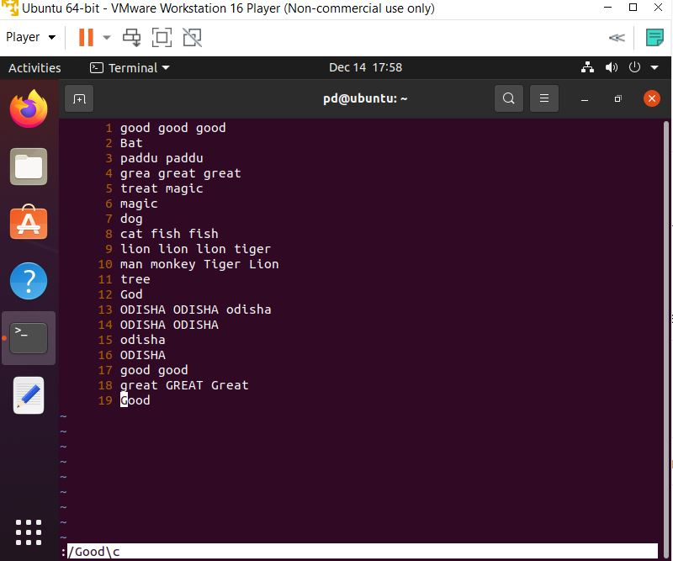

1. How to search an exact pattern?

Sol : **:/pattern**

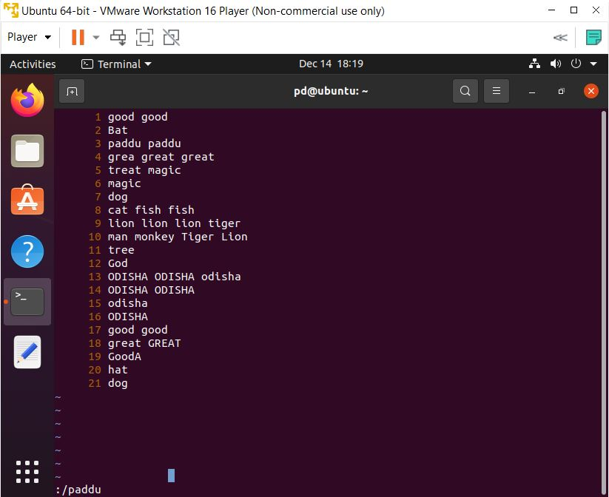

1. How to search and replace the pattern only in 4th line and 10th line?